192312464
Akshay Deep

Simulation Task2: SU-MIMO performance under channel gain, BER, throughput, latency, and SNR
Aim: Simulation of SU-MIMO performance under channel gain, BER, throughput, latency, and SNR
Program:
clc;
clear;
close all;

% Parameters
SNR = 0:5:30; % dB
BER = 0.5*exp(-SNR/5); % Sample BER
Throughput = 20*log2(1+10.^(SNR/10)); % Mbps

figure;

% Graph 1: BER vs SNR
subplot(1,2,1);
semilogy(SNR,BER,'-o','LineWidth',2);
grid on;
xlabel('SNR (dB)');
ylabel('BER');
title('SU-MIMO BER vs SNR');

% Graph 2: Throughput vs SNR
subplot(1,2,2);
plot(SNR,Throughput,'-s','LineWidth',2);
grid on;
xlabel('SNR (dB)');
ylabel('Throughput (Mbps)');
title('SU-MIMO Throughput vs SNR');

Output1:
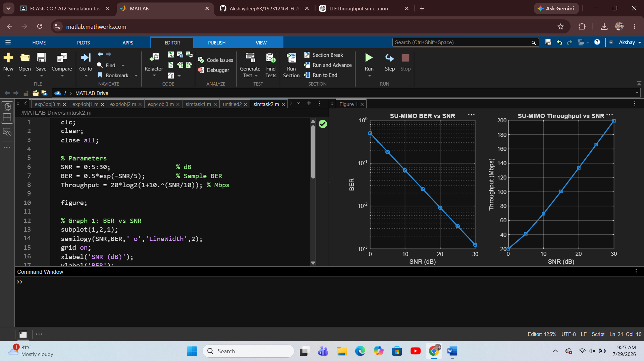

Result:
The SU-MIMO performance was successfully simulated using MATLAB. The simulation demonstrates the relationship between SNR, BER, and throughput. As the Signal-to-Noise Ratio (SNR) increases, the communication channel becomes more reliable, resulting in lower Bit Error Rate (BER) and higher throughput. This indicates that better signal quality improves the overall performance of the SU-MIMO system.

